# CREATE A SERVICE CALL - STANDARD

**COMPLETE A DAILY SERVICE TIMESHEET (EXCEL)**

## Introduction

You’ll complete a daily timesheet to document how long you’ve worked on a given day and what job(s) your time was spent on.

The information on your timesheet is used to:

* calculate your weekly wage and any allowances

AND

* allocate your labour to the relevant service call segments.

This QRG relates to the Microsoft Excel template version of the daily timesheet you’ll complete on a laptop or PC. This template has been updated (17 May 2018) to include additional formulas, which should make data entry easier without sacrificing data capture.

## TIME ENTRY

**TEMPLATE OVERVIEW**

There are three sheets in the template:

* Daily Time Sheet (1)
* Daily Time Sheet (2)
* Daily Time Sheet (3)

Each sheet can handle a maximum of 6 time entries; a single segment start and stop time.

Sheet (2) and Sheet (3) will have some read-only fields, as they’re populated from Sheet (1).

**BASIC FEATURES**

1. This field is automated.
2. Any info you enter in these fields duplicates to Sheet (2) and Sheet (3).
3. This is the grand total hours for Sheet (1), Sheet (2) and Sheet (3).
4. This is the summed hours for each individual time entry.

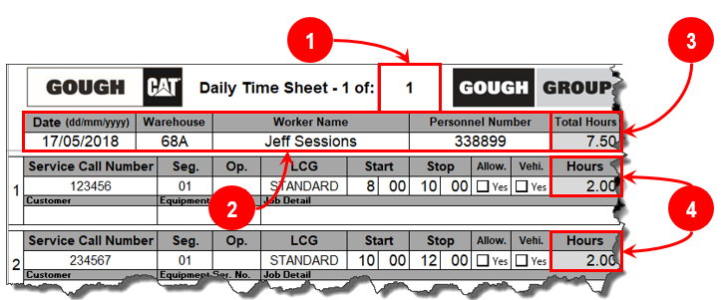

**NEW START AND STOP TIME FEATURE**

1. The ‘Stop’ time in a time entry populates the ‘Start’ time on the next time entry.
2. ‘BREAK’ is available if you want to show your meal break; the ‘Hours’ will show as ‘0.00’.

*If you want to remove a start or stop time, use the ‘0’ key instead of deleting the value.*

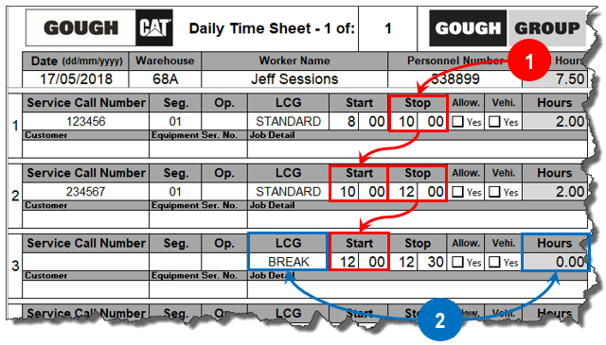

**NEW ALLOWANCE FEATURE**

1. Tick ‘***Allow***’ if you’re eligible for an allowance on a time entry.
2. That time entry’s service call and segment will duplicate to ‘Allowances Claimed’.
3. Select the allowance you’re claiming.
4. Define the quantity and describe the allowance.

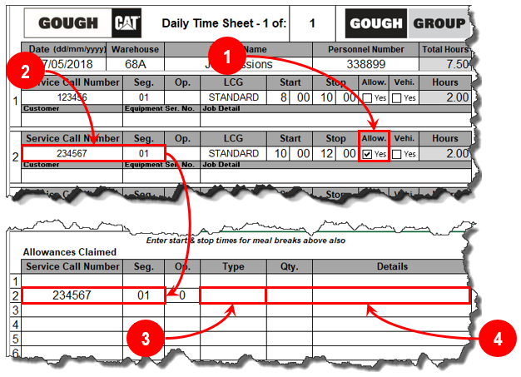

**NEW VEHICLE MILEAGE FEATURE**

1. Tick ‘***Vehi***’ if you had travel on a time entry.
2. That time entry’s service call and segment will duplicate to ‘Vehicle Recoveries’.
3. Define the mileage and the vehicle registration number or asset number.

